Data 1

<https://www.very.ie/men/big-tall/e/b/129806,1977.end?pageNumber=3>

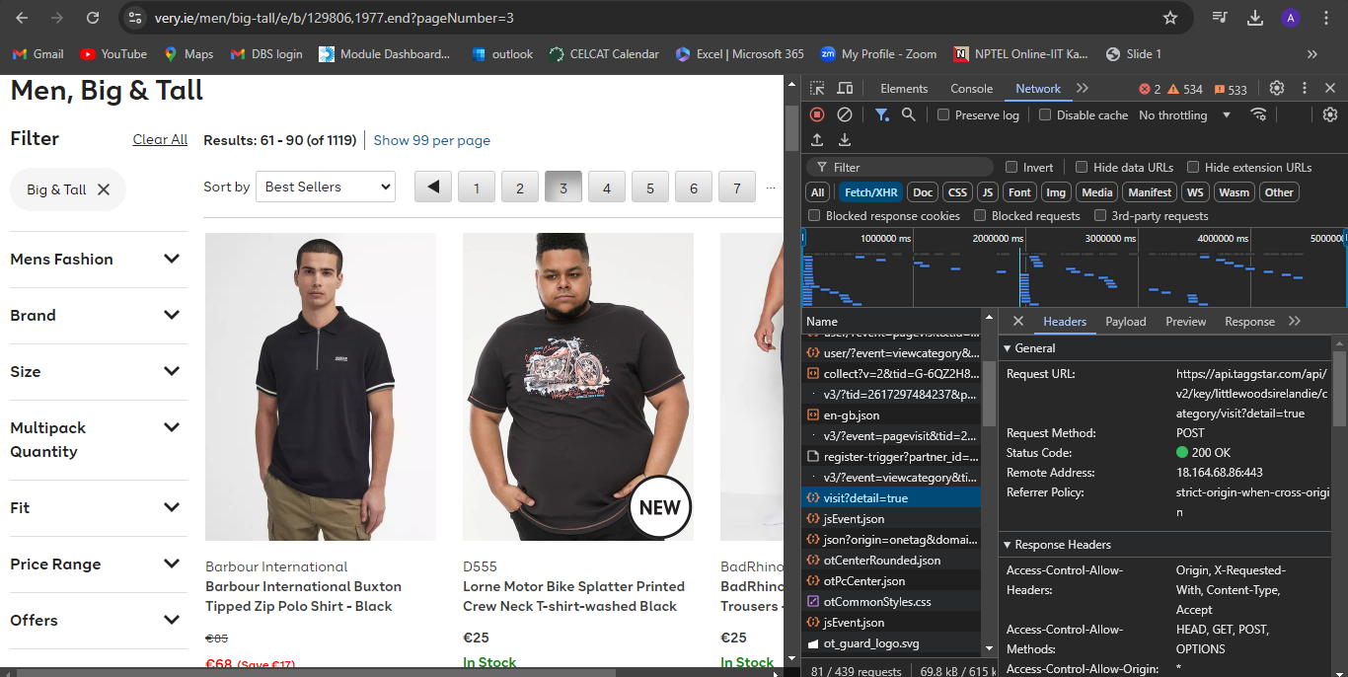

Data 2